Image | 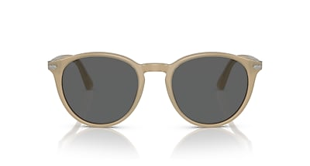
Brand | OLIVER PEOPLES
Model Name | PO3152S
Price | RS 2790
PRODUCT DETAILS

